**Title Page**

**Title**: Trends and Patterns of Human Papillomavirus Vaccination Rates on Long Island, 2012-2023: An Evaluation of Disparities in Vaccine Uptake

**Abbreviated Title**: Trends and Patterns of Human Papillomavirus Vaccination Study on Long Island, 2012-2023

**Authors:**

Zihan Ding1, Jianyuan Deng PhD2, Linda Mermelstein, MD, MPH3, Barbara Nemesure, PhD3,4, Tyler Osborne1, Fusheng Wang PhD1,2

1. Department of Computer Science, Stony Brook University, Stony Brook, NY,
2. Department of Biomedical Informatics, Stony Brook University, Stony Brook, NY,
3. Stony Brook Cancer Center, Stony Brook, NY,
4. Department of Family, Population and Preventive Medicine, Stony Brook Medicine, Stony Brook, NY

**Corresponding Author**

Fusheng Wang PhD

Department of Biomedical Informatics

Department of Computer Science

Stony Brook University

2313D Computer Science

Stony Brook, NY 11794-8330

Tel: (631)632-2594

Email: [fusheng.wang@stonybrook.edu](mailto:fusheng.wang@stonybrook.edu)**Abstract**

**Introduction:**  The Advisory Committee on Immunization Practices (ACIP) advised vaccinating young adults against Human Papillomavirus (HPV) in 2006, aiming to prevent HPV-related cancers and genital warts. As these preventive measures have spread rapidly, understanding vaccination patterns is essential for informing targeted public health interventions. This study aimed to explore the demographic disparities, temporal trends, and geographical patterns of HPV vaccine administration by analyzing large-scale immunization registry vaccine data for Long Island (LI) (Nassau and Suffolk Counties), New York (NY).

**Methods:** The vaccine registration data retrieved from the New York State Immunization Information System (NYSIIS) was used to assess the HPV vaccine administration rate from 2012 to 2023. Patients’ demographic information and regional variations were evaluated to identify the disparities between different subgroups. The analysis was conducted between 2023 and 2024.

**Results:** The HPV vaccination rate among LI children ages 9 to 13 demonstrates a growth of 284.43% from 2012 to 2019 and a slight decrease of 5.04% around 2020. Around 68.07% of individuals received their first dose before their 15th birthday and 24.95% of them followed the recommended routine to receive 2 doses in half a year. Spatially, eastern LI consistently holds a higher HPV vaccination rate than Northwestern LI.

**Conclusions**: The rising trend in HPV vaccination coverage on LI with a modest drop around 2020 indicates the likely impact of COVID-19 pandemic. Additional attention is called to be paid to the regions with the lower uptake rates given the uneven distribution of the vaccine coverage to prevent HPV-related cancers.

**Introduction**

Human Papillomavirus (HPV) infection, which is the most common sexually transmitted infection, causes approximately 33700 cases of cancer every year in the United States.1-23 The HPV vaccine was designed to prevent infection by certain types of HPV, which can lead to six types of cancer (anal, cervical, oropharyngeal, vulvar, vaginal, and penile) and genital warts. It is one of the most effective ways to prevent HPV-related diseases.4,5 The vaccine is typically administered through a series of injections. In the United States, the HPV vaccine is widely available and recommended for adolescents and young adults.6 Various campaigns and initiatives have been launched to increase awareness and uptake of the vaccine.4,7 In 2022, 38.6% of children ages 9 to 17 had received one or more HPV vaccine doses.8 Additionally, school-based vaccination programs and community efforts have been utilized to reach adolescents globally and are standard in many countries.9,10

The HPV immunization schedule followed a recommended protocol maximizing long-term protection against HPV-related diseases. Guidelines established by NYSDOH supported the 'Start at 9' initiative by the National Human Papillomavirus Vaccination Roundtable, promoting the recommendation for routine HPV vaccination to commence ages 11 to 12 starting as early as age 9.4,11 When the HPV vaccine is given to individuals before their 15th birthdays, only two doses, separated by a minimum of 6 months, are required to complete the vaccination series.  However, for those who initiate the HPV vaccination series at age 15 or older, or individuals age 9 to 26 with a weakened immune system, three doses are necessary for full protection. In the case of three doses, the second dose should be administered 1 to 2 months after the first, and the third dose should be given at least 6 months after the initial dose.12 The minimum interval between the second and third doses is 12 weeks, and between the first and third doses is 5 months. Vaccination schedules may be used by healthcare providers give parents and patients recommendation about the importance of completing the full series for maximum benefit.13,14

In New York, like in many other states, efforts have been made to ensure accessibility to the vaccine through healthcare providers, clinics, and public health programs. The New York State (NYS) government provided various measures to cover the expenses of HPV vaccination to promote its uptake among young people.15 Both women’s and men’s HPV vaccination coverage in NYS is higher than the average HPV vaccination rate nationally according to the official report released by NYSDOH in 2020.16

The purpose of this study is to better understand the HPV vaccination trends and patterns on Long Island (LI) by using data analytics and statistical tools. LI holds a diverse population with varying socio-economic backgrounds, cultural norms, and healthcare access, which can profoundly influence vaccination rates.16 The Bureau of Immunization within the NYSDOH is dedicated to enhancing the well-being of children in New York State by minimizing or eradicating vaccine-preventable diseases that impact the state's youth.18,19 This helps epidemiologic researchers and health providers understand how interventions and demographics affect vaccine uptake and lets them tailor public health efforts to LI’s specific needs. Additionally, analyzing geographic patterns of vaccination may help identify the impact of socioeconomic differences, cultural norms, and healthcare access on HPV vaccination rates. Therefore, focusing on HPV vaccination patterns on Long Island enables a comprehensive understanding of regional dynamics and facilitates targeted public health strategies to improve vaccine uptake and reduce the burden of HPV-related cancer on Long Island.

**Methods**

Study Sample

This study utilized patient vaccination data from NYSIIS (New York State Immunization System), managed by NYSDOH, collecting immunization records for individuals from 2008 to prevent vaccine-preventable diseases among children in the state.18 To protect patient privacy, the NYSDOH data presents case counts associated with zip codes rather than individual addresses.20 Our research is centered on  zip codes belonging to Long Island (LI) (Nassau and Suffolk Counties).21

We filtered data using “Gardasil” to identify patient visits for the HPV dose. Due to experimental requirements, we also gathered Tdap (Tetanus, Diphtheria, and Pertussis) vaccine-relevant data. Only people who received either HPV or Tdap vaccinations were included in our analysis. In total, 2173576 patients’ visit records, and 1120113 unique patients (473995 HPV vaccinated patients) were included in our analysis. We also utilized patient-level information, including demographics, vaccination months and years, provider information, and the patient’s zip code.

In New York State, children enrolled in daycare as well as those in pre-K through 12th grade are obligated to receive all necessary vaccines including Tdap doses according to the recommended timetable to be eligible for school attendance.22 In our study, we used the number of school-aged children who got the Tdap vaccination as the reference value to calculate the HPV vaccination rate. We used the number of teenagers aged 9-13 years who receive the HPV vaccination as the numerator, and the number of teenagers aged 9-13 years who either received the HPV or Tdap vaccinations as the denominator.

Statistical Analysis

1. Patients Demographic Analysis

The patient information was aggregated by the unique client ID and sorted by the vaccination year and month. Only initial visits are counted if a patient has multiple visits.  In our study, we utilize patient-level data from 2008 to 2023. Our target group consisted of children aged 9 to 13. To include all the Tdap vaccine data in this timeframe, we needed to exclude the year range 2008 to 2011 as there were missing Tdap records before NYSIIS was established. Including these years might have caused an inaccurate denominator when calculating the rate. A comprehensive analysis was conducted to analyze gender, race, and ethnic disparities among those vaccinated patients.

1. Temporal Analysis over 2012 to 2023

All the patient-level data were aggregated by the vaccine year and month from those time-series data to visualize the trend and seasonality. In this section, if a person received multiple doses, only the initialized time was used in the temporal analysis. The number of children from 9 to 13 who either received Tdap or HPV vaccines in a specific year were counted as the denominator and the numerator was the number of children from 9-13 who received the HPV vaccination. The result will conclude the HPV vaccination rate on Long Island and separately from Suffolk and Nassau from 2012 to 2023. Additionally, we analyzed seasonal vaccination rate patterns.

1. Geographical Spatial Analysis

We visualized the zip code level spatial distribution of HPV vaccination rate calculated by the formula provided in previous sections using geographical maps. The shade of color in each block represents the rate of HPV vaccination. All maps were generated using ArcGIS Desktop 10.5 (Esri, Redlands CA).

Approval was obtained from the NYSDOH and a Stony Brook University IRB before dataset acquisition and analysis (838962_MODCR008). As the data were obtained from an administrative database maintained by NYS, no informed consent was needed for study participation. All study analyses were completed between 2023 and 2024.

**Results**

HPV Vaccination Patients Demographic Overview

Table A provides an overview of patient demographics, including various groups categorized by demographics. Each row in the table represents a distinct demographic category, while columns display the number of HPV-vaccinated patients in that group (p < 0.0005). The table indicates that there is a slightly lower number of female patients compared to male patients. In our database, the largest group as defined by race is white, followed by Black and Asian (all p < 0.0005).

Figure 1 illustrates the age distributions of different groups of patients receiving the HPV vaccination. The histogram reveals that most patients receive their first dose between 10 and 14 years of age. There is a slight variation between genders, with females (year 10-11) initiating vaccination slightly earlier than males (year 11 to 12). Hispanic individuals tend to start their HPV vaccination series sooner than non-Hispanic individuals.

Temporal Trend and Doses Series Completeness Analysis

Figure 2 indicates the HPV vaccine initialization rate on Long Island among children aged 9-13 years from 2012 to 2023. The overall rate went up by 284.43% from 2012 to 2019 and is followed by a slight decline (5.04%) in 2020 and 2021. This may have been caused by the Covid-19 pandemic: the rate rose smoothly from 2021 to 2023, when the acute phase of the pandemic ended. This trend was evaluated via ordinary least squares (OLS) regression and emphasizes the significance of the linear trend (p < 0.0005).

In Figure 2, subfigure A, both males and females experienced a similar trend but the starting point for boys is slightly lower than girls. The  U.S. Food and Drug Administration (FDA) approval of HPV vaccination for girls began in 2006, while it was recommended for boys until 2011.5,23 This discrepancy may have led to boys initiating the vaccination later than girls. In Figure 2, subfigures B and C, Nassau and Suffolk counties show similar trends from 2012 to 2023 (p > 0.05). Both have a statistically significant correlation to all gender rates over the years. Disparities among different racial and ethnic groups are shown in subfigure D: non-Hispanic and white people’s HPV vaccination rates are consistently lower than people who identified themselves as Black and Hispanic among those children aged 9-13 years. Efforts to improve vaccination awareness and access are crucial for all racial and ethnic groups. Figure 2 also indicates HPV vaccinations are mostly offered to children in the summer as public and private schools in New York state require vaccination at the entry of school in fall.22 This can be helpful for the health provider and researcher to gain more attention in this period.

Regarding the completeness of the whole vaccination series, the nested pie chart A in Figure 3 represents the dose schedule among all the HPV vaccinated patients in our database. According to the CDC’s HPV immunization schedule guideline, we divided all the patients by the age at the first HPV vaccine dose. Initial age < 15 and initial vaccination after the 15th birthday was represented by the red and blue parts in the figure. Approximately 45.1% of the first group patients completed the recommended doses in 12 months and 37% of the second group finished their whole 3 doses series. Adolescents receiving their first dose before age 15 were more likely to finish than teens starting later, with over 82.58% of the under-15 group completing the series compared to about 45.75% of the over-15 group. Figure 3, Subfigures B and C illustrate the initialization rate and complete rate disparities among gender, race, and ethnicity groups. The number on the bars represents the portion of completed patients towards all patients who initiated their HPV vaccination schedule. Of those who started the vaccine, about 70.82% of them completed the full vaccination sequence. Girls finish the vaccine series slightly more often than boys and Asians had the highest completion rate at nearly 75%.

Geographic Patterns in Zip code Level

We chose 8 typical years of geographical maps in Figure 4 to represent the spatial distribution of HPV vaccination administration rate on Long Island (LI) among adolescents aged 9-13 years. In the significant test, OLS regression was utilized to verify the linear trend and over 82% of the zip code area rate has a p < 0.05 and the linear trend has been proved. For the overall difference, we use F-test (p >0.05) which means we cannot reject the hypotheses that are not the same among those zip code areas.  The HPV vaccination rate on the eastern side of LI consistently exceeds that on the western side. Especially the western LI. Riverhead (zip code 11901) became the highest HPV vaccination rate area on LI. This can be caused by various factors such as socioeconomic status, healthcare access and awareness, culture and social norms, and media influence. There is also a densely populated area in the eastern region, near the north shore; however, significant disparities exist. This information can raise awareness among healthcare providers and researchers, prompting them to monitor and address the spread and popularity of HPV vaccination in areas where rates are low. A collaborative effort involving healthcare professionals, policymakers, educators, and the community is essential for successful HPV vaccine promotion on Long Island.

**Discussion**

This research fills the knowledge gaps related to HPV vaccination trends and patterns on Long Island (LI) by applying epidemiological and data analytics techniques to assess the geographic, temporal, and personal demographics of HPV-vaccinated individuals. The HPV vaccination rate across LI has gradually increased over the past decade with a slight drop during the COVID-19 pandemic. This trend aligns with national increases in HPV vaccination rates, as reported by the New York State Department of Health and the Centers for Disease Control and Prevention among teenagers.8,16,24 The child vaccination rate rose each year until 2019, which had the highest rate at about 44.99%. However, when COVID-19 hit in early 2020, the vaccination rate dropped slightly (a 5.04% decrease from 2019 to 2021) in the HPV vaccination rate. Since then, the vaccination rate has gradually recovered but hasn't reached 2019’s maximum rate yet. Another finding is that there are disparities in the HPV vaccination rates among different racial and ethnic groups. For example, Hispanic people had a consistently higher vaccination rate than other ethnicities. Segmenting by zip code, eastern Long Island is doing better than western Long Island with 82% of the ZIP codes testing the linear trend by the OLS regression. These findings support the continued encouragement of early vaccination and call for special efforts on western LI’s north shore where fewer school-aged adolescents are getting vaccinated.

Our study adds to what we know from other recent studies in the past decade. The New York State Department of Health releases cancer-related statistics including HPV-related cancer and HPV vaccination every five years, helping us track medium and long-term relationships between HPV vaccination and disease incidence rates.16,24,25 In 2016, Nadja A. Vielot and her team found that older boys and adolescents living in rural areas didn’t get the HPV vaccine as much as other vaccines like Tdap or MenACWY.26 Our findings are similar: boys' and especially older children’s HPV vaccination rates are both quite lower than girls. Erika and her team focus on college students and emphasize that work is needed to increase women’s HPV vaccination rates within the said demographic.27 This aligns with our finding that older teens' HPV vaccination completion rate is vitally lower than that of younger children. Szu-Ta Chen and his team utilized the commercial insurance database in the US and indicated that HPV vaccination coverage among insured children still needs more efforts to improve.28,29 This is like what we saw with different places in Long Island—some areas and some groups required more effort to spread the HPV vaccination. Lastly, Kalyani et al. found that the primary reason for patients not initiating the HPV vaccination is the safety concern.30 We need to put increasing effort into the intervention of unvaccinated teens and also work to correct the false information spreading on social media that greatly influences public opinion.31

Limitations of this study

One limitation of our study pertains to the calculation of HPV vaccination rates among individuals aged 9 to 13 years old. Our analysis relies on using the number of patients who have received the HPV or Tdap vaccination as the denominator for calculating HPV vaccination rates within this age group. However, it's important to note that this denominator may not accurately represent the total population within the 9 to 13 age range. Additionally, there is a possibility that patients may have received the Tdap vaccine in other states but received the HPV vaccine in New York State, leading to potential discrepancies in our calculations. These factors introduce bias and limitations to our study's findings, highlighting the need for cautious interpretation and consideration of alternative methodologies for accurately assessing HPV vaccination rates among adolescents.

Another limitation of our study is the potential impact of population migration between the years 2012 and 2023, which falls outside the scope of our control in this experiment. Population migration, whether internal or external, can influence the composition and characteristics of the population under study. Individuals may relocate to different regions or countries for various reasons, such as job opportunities, economic factors, or personal circumstances, leading to changes in the demographics of the population. This demographic shift can introduce bias and confound the interpretation of our findings, particularly when assessing long-term trends in HPV vaccination rates. Moreover, migration patterns may vary across different demographic groups, potentially affecting the representation and generalizability of our study results. Therefore, while our study provides valuable insights into HPV vaccination patterns within a specific timeframe, it is essential to acknowledge the limitations imposed by population migration and consider its potential impact on the validity and reliability of our findings.

**Conclusion**

In conclusion, our study provides valuable insights into the HPV vaccination patterns and trends among adolescents aged 9 to 13 years old on Long Island, New York State. We provided several aspects to reveal the user profiles of the HPV vaccination patients and exhibit the yearly trend of the HPV vaccination rate from 2012 to 2023. Ultimately, our study contributes to the ongoing efforts to promote public health and advance our understanding of HPV vaccination practices among adolescents.

In future research, analysis of HPV vaccination trends and patterns could be analyzed in smaller geographic units, such as at the census tract level. This could help us learn more about what is happening in specific communities. We can also enlarge our research scale to the whole of New York States. This way, we could obtain a better understanding of how many people are getting vaccinated in both cities and rural areas. Our methodology provides a great opportunity to assist researchers, health providers, and clinic physicians in understanding the HPV vaccination utilization among various geographic regions and diverse population groups. Such investigation would inform adaptive strategies for policymakers and healthcare providers to address the need for HPV vaccine promotion and to better understand the pandemic's repercussions on HPV-related health outcomes.

**Conflict of Interest Disclosures**

The authors disclose no conflicts of interest.

**Funding/Support:**

This work was supported by no external funding sources.

**Role of the Funder/Sponsor:**

This work was supported by no external funding sources.

**Dissemination to participants and related patient and public communities:**

There are no plans to disseminate the results of the research to study participants or the relevant patient community.

**References**

1. M. Saraiya et al., “US Assessment of HPV Types in Cancers: Implications for Current and 9-Valent HPV Vaccines,” JNCI: Journal of the National Cancer Institute, vol. 107, no. 6, Jun. 2015, doi: [10.1093/jnci/djv086](https://doi.org/10.1093/jnci/djv086).
2. L. Lin, V. B. Benard, A. Greek, N. A. Hawkins, K. B. Roland, and M. Saraiya, “Racial and ethnic differences in human papillomavirus positivity and risk factors among low-income women in Federally Qualified Health Centers in the United States,” Preventive Medicine, vol. 81, pp. 258–261, Dec. 2015, doi: [10.1016/j.ypmed.2015.08.027](https://doi.org/10.1016/j.ypmed.2015.08.027).
3. M. Roman and J. J. Chen, “Understanding Factors Affecting Health Providers’ Perceptions of Pharmacist Roles in HPV Vaccine Administration,” SOCIAL WELFARE, vol. 83, no. 4, 2024.
4. L. E. Markowitz et al., “Human papillomavirus vaccination: recommendations of the Advisory Committee on Immunization Practices (ACIP),” MMWR Recomm Rep, vol. 63, no. RR-05, pp. 1–30, Aug. 2014.
5. S. Ljubojević, “The human papillomavirus vaccines,” Acta Dermatovenerol Croat, vol. 14, no. 3, p. 208, 2006.
6. C. L. Ejezie, I. Osaghae, S. Ayieko, and P. Cuccaro, “Adherence to the Recommended HPV Vaccine Dosing Schedule among Adolescents Aged 13 to 17 Years: Findings from the National Immunization Survey-Teen, 2019–2020,” Vaccines, vol. 10, no. 4, p. 577, Apr. 2022, doi: [10.3390/vaccines10040577](https://doi.org/10.3390/vaccines10040577).
7. “American Cancer Society Launches Campaign to Eliminate Cervical Cancer,” American Cancer Society MediaRoom. Accessed: Apr. 23, 2024. [Online]. Available: <https://pressroom.cancer.org/HPVcancerfreelaunch>
8. M. Villarroel, A. Galinksy, P.-J. Lu, C. Pingali, and C. Valenzuela, “Human Papillomavirus Vaccination Coverage in Children Ages 9–17 Years: United States, 2022,” National Center for Health Statistics (U.S.), Feb. 2024. doi: [10.15620cancer data/cdc:145593](https://doi.org/10.15620/cdc:145593).
9. M. B. Shin et al., “Multilevel perspectives on school-based opportunities to improve HPV vaccination among medically underserved adolescents: Beyond school entry mandates,” Human Vaccines & Immunotherapeutics, vol. 19, no. 2, p. 2251815, Aug. 2023, doi: [10.1080/21645515.2023.2251815](https://doi.org/10.1080/21645515.2023.2251815).
10. “HPV vaccination introduction worldwide and WHO and UNICEF estimates of national HPV immunization coverage 20102019.”, [Online]. Available: <https://pubmed.ncbi.nlm.nih.gov/33388322/>
11. Human Papillomavirus (HPV). New York City Health website. <https://www.nyc.gov/site/doh/health/health-topics/human-papillomavirus-hpv.page>. Accessed November 29, 2023.
12. E. Meites, “Use of a 2-Dose Schedule for Human Papillomavirus Vaccination — Updated Recommendations of the Advisory Committee on Immunization Practices,” MMWR Morb Mortal Wkly Rep, vol. 65, 2016, doi: [10.15585/mmwr.mm6549a5](https://doi.org/10.15585/mmwr.mm6549a5).
13. L. E. Widdice, D. I. Bernstein, A. C. Leonard, K. A. Marsolo, and J. A. Kahn, “Adherence to the HPV Vaccine Dosing Intervals and Factors Associated With Completion of 3 Doses,” Pediatrics, vol. 127, no. 1, pp. 77–84, Jan. 2011, doi: [10.1542/peds.2010-0812](https://doi.org/10.1542/peds.2010-0812).
14. Rao M IS, Kasi SG, Dhir SK, Wadhwa A, Rajsekhar B, Kumar CM, Lalwani S, Shenoy B, Kesavan TMA, Kalyani S, Khadke R, Chatarjee K, Kinjawadekar U, Saxena V, Basavaraja GV. Indian Academy of Pediatrics (IAP) Advisory Committee on Vaccines and Immunization Practices (ACVIP): Recommended Immunization Schedule (2023) and Update on Immunization for Children Aged 0 Through 18 Years. Indian Pediatr. 2024 Feb 15;61(2):113-125. Epub 2024 Jan 15. PMID: 38243749
15. “NYSDOH HPV web page.” [Online]. Available: <https://www.health.ny.gov/diseases/communicable/human_papillomavirus/#:~:text=The%20New%20York%20State%20Department,9%20years%20as%20routine%20practice.>
16. HPV-Related Cancer Incidence and HPV Vaccination Rates in New York State, 2015-2019. <https://www.health.ny.gov/statistics/cancer/docs/hpv_related_cancers_and_vaccination_rates.pdf>.
17. E. R. Schoenfeld et al., “covi, Temporal, and Sociodemographic Differences in Opioid Poisoning,” American Journal of Preventive Medicine, vol. 57, no. 2, pp. 153–164, Aug. 2019, doi: [10.1016/j.amepre.2019.03.020](https://doi.org/10.1016/j.amepre.2019.03.020).
18. “New York State Immunization Information System (NYSIIS).” Accessed: Apr. 14, 2024. [Online]. Available: <https://www.health.ny.gov/prevention/immunization/information_system/>
19. E. M. Rosenthal et al., “COVID-19 Vaccination and Hospitalization Among Persons Living With Diagnosed HIV in New York State,” J Acquir Immune Defic Syndr, vol. 93, no. 2, pp. 92–100, Jun. 2023, doi: [10.1097/QAI.0000000000003177](https://doi.org/10.1097/QAI.0000000000003177).
20. Jacquez GM, Greiling DA. Local clustering in breast, lung and colorectal cancer in Long Island, New York. Int J Health Geogr. 2003 Feb 17;2(1):3. doi: 10.1186/1476-072x-2-3. PMID: 12633503; PMCID: PMC151676.
21. “Long Island Zip Codes - Zip Codes for Nassau County & Suffolk County | LongIsland.com.” Accessed: Apr. 14, 2024. [Online]. Available: <https://www.longisland.com/zip-codes.html#google_vignette>
22. “School Immunization Requirements.” Accessed: May 13, 2024. [Online]. Available: <https://www.health.ny.gov/prevention/immunization/schools/school_vaccines/>
23. “What Is the HPV Vaccine?,” Cleveland Clinic. Accessed: Apr. 15, 2024. [Online]. Available: <https://my.clevelandclinic.org/health/treatments/21613-hpv-vaccine>
24. HPV-Related Cancer Incidence and HPV Vaccination Rates in New York State, 2013-2017. https://www.health.ny.gov/statistics/cancer/docs/hpv_related_cancer_13-17.pdf
25. “Cancer Data and Statistics.” Accessed: Apr. 29, 2024. [Online]. Available: <https://www.health.ny.gov/statistics/cancer/>
26. N. A. Vielot, A. M. Butler, M. A. Brookhart, S. Becker-Dreps, and J. S. Smith, “Patterns of Use of Human Papillomavirus and Other Adolescent Vaccines in the United States,” Journal of Adolescent Health, vol. 61, no. 3, pp. 281–287, Sep. 2017, doi: [10.1016/j.jadohealth.2017.05.016](https://doi.org/10.1016/j.jadohealth.2017.05.016).
27. E. L. Thompson, C. A. Vamos, C. Vázquez-Otero, R. Logan, S. Griner, and E. M. Daley, “Trends and predictors of HPV vaccination among U.S. College women and men,” Preventive Medicine, vol. 86, pp. 92–98, May 2016, doi: [10.1016/j.ypmed.2016.02.003](https://doi.org/10.1016/j.ypmed.2016.02.003).
28. L. A. Blewett, K. T. Call, J. Turner, and R. Hest, “Data Resources for Conducting Health Services and Policy Research,” Annu Rev Public Health, vol. 39, pp. 437–452, Apr. 2018, doi: [10.1146/annurev-publhealth-040617-013544](https://doi.org/10.1146/annurev-publhealth-040617-013544).
29. S.-T. Chen, K. F. Huybrechts, B. T. Bateman, and S. Hernández-Díaz, “Trends in Human Papillomavirus Vaccination in Commercially Insured Children in the United States,” Pediatrics, vol. 146, no. 4, p. e20193557, Oct. 2020, doi: [10.1542/peds.2019-3557](https://doi.org/10.1542/peds.2019-3557).
30. K. Sonawane et al., “Factors associated with parental human papillomavirus vaccination intentions among adolescents from socioeconomically advantaged versus deprived households: a nationwide, cross-sectional survey,” The Lancet Regional Health – Americas, vol. 31, Mar. 2024, doi: [10.1016/j.lana.2024.100694](https://doi.org/10.1016/j.lana.2024.100694).
31. J. Du et al., “Using Machine Learning–Based Approaches for the Detection and Classification of Human Papillomavirus Vaccine Misinformation: Infodemiology Study of Reddit Discussions,” J Med Internet Res, vol. 23, no. 8, p. e26478, Aug. 2021, doi: [10.2196/26478](https://doi.org/10.2196/26478).

**Figure Legends**

Figure 1. Age distributions of patients who received one or more doses of HPV vaccine by gender, race, and ethnicity.

Figure 2. HPV vaccine initiation rate among 9- to 13-year-old children in Nassau and Suffolk Counties, New York. The rate here was calculated by the number of children who already initialized the HPV vaccination divided by the number of children either receive the HPV vaccination or Tdap vaccination.

Figure 3. The completeness of the HPV vaccinated individuals on the Long Island, New York State, 2012-2023. The figures are generated according to the CDC HPV vaccination guidelines. Figure 4. Geographical maps of HPV vaccination rates on Long Island, New York (Nassau and Suffolk Counties) among children ages 9-13 by zip code. The rate was calculated by the number of children receiving one or more HPV vaccine dose divided by the number of children who received HPV, Tdap or both vaccines.

1

|  |  |  |  |  |  |  |  |  |  |  |  |  |  |  |  |
| --- | --- | --- | --- | --- | --- | --- | --- | --- | --- | --- | --- | --- | --- | --- | --- |
| **Table A**. Summary of Aggregation Information of HPV Vaccination Patients on the Long Island. (The patients from the entire NYSIIS database) 1 | | | | | | | | | | | | | | P value5 | |
|  |  | 2012 | 2013 | 2014 | 2015 | 2016 | 2017 | 2018 | 2019 | 2020 | 2021 | 2022 | 2023 | Linear | Overall |
| Gender | Male | 20574 | 38493 | 56711 | 77367 | 99946 | 120951 | 142650 | 163788 | 179135 | 193555 | 209654 | 225007 | <0.0005 | <0.0005 |
| Female | 55221 | 70823 | 86802 | 106035 | 126958 | 146873 | 166948 | 187044 | 202339 | 216664 | 232859 | 248334 | <0.0005 | <0.0005 |
| Age | 9-132 | 16458 | 23004 | 28215 | 36383 | 44374 | 49557 | 54729 | 58983 | 56735 | 52808 | 51848 | 51522 | <0.0005 | <0.0005 |
| 14-25 | 59331 | 86296 | 115183 | 146644 | 181202 | 214563 | 246876 | 277885 | 302238 | 322171 | 338127 | 348376 | <0.0005 | <0.0005 |
| >=263 | 162 | 239 | 410 | 725 | 1728 | 4148(1)4 | 8468 | 14473(3) | 23030(1) | 25799(3) | 53149(3) | 74101(6) | <0.0005 | <0.0005 |
| Race and Ethnic | White | 32635 | 49774 | 66838 | 86873 | 109218 | 130939 | 152995 | 174070 | 190051 | 203714 | 218956 | 233244 | <0.0005 | <0.0005 |
| Black | 6643 | 9529 | 12635 | 16727 | 21117 | 25031 | 28954 | 32860 | 35569 | 38436 | 41532 | 44677 | <0.0005 | <0.0005 |
| Asian | 3990 | 5803 | 7830 | 10642 | 13637 | 16675 | 20017 | 23285 | 25957 | 28451 | 31613 | 34801 | <0.0005 | <0.0005 |
| Hispanic | 14329 | 21043 | 29631 | 39846 | 51594 | 61855 | 72568 | 84262 | 92393 | 101611 | 112155 | 122192 | <0.0005 | <0.0005 |
| Non-Hispanic | 38598 | 58515 | 78026 | 101732 | 127471 | 152483 | 177657 | 201188 | 219371 | 234853 | 252642 | 269436 | <0.0005 | <0.0005 |
| Total |  | 75954 | 109540 | 143808 | 183751 | 227304 | 268268 | 310072 | 351339 | 381998 | 410773 | 443121 | 473995 | <0.0005 | <0.0005 |

1. The absolute numbers here represent the number of individuals in the specific group with one or more HPV vaccine doses.
2. Children ages 9- to 13-year-old are the targeted population studied in this paper.
3. HPV vaccination is not recommended for everyone older than age 26 years.
4. The numbers in the parentheses show the newly added patients who initiated the HPV vaccination during that year.
5. The OLS regression was used to test the P-value of each yearly trend.

**Figure 1**. Age distributions of patients who received one or more doses of HPV vaccine by gender, race, and ethnicity.

1. Male patients with one or more HPV Vaccine doses.
2. Black people with one or more HPV Vaccine doses.
3. Asian people with one or more HPV Vaccine doses.
4. Non-Hispanic people with one or more HPV Vaccine doses.
5. Hispanic people with one or more HPV Vaccine doses.
6. White people with one or more HPV Vaccine doses.
7. All patients with one or more HPV Vaccine doses
8. Female patients with one or more HPV Vaccine doses.

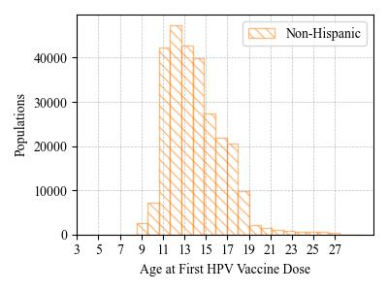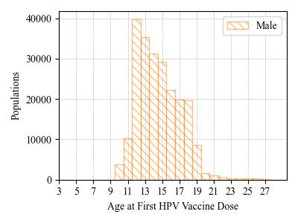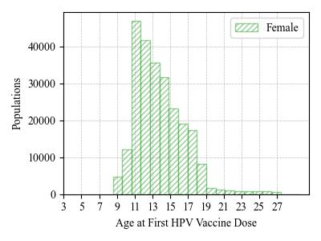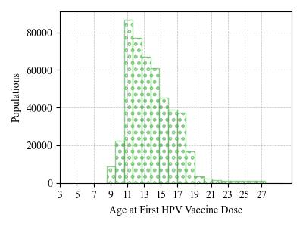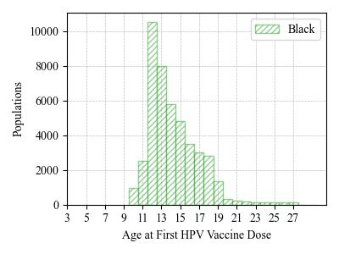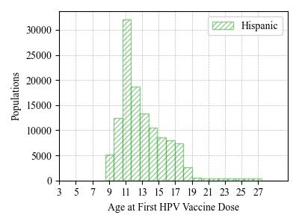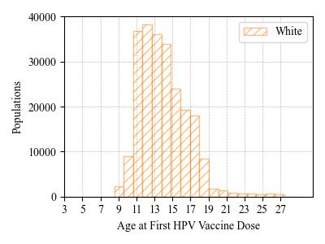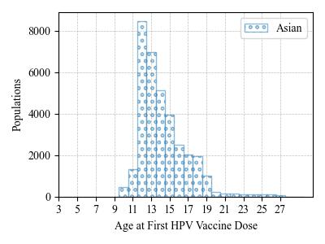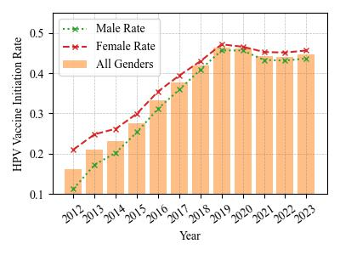

1. HPV vaccine initiation rate for LI children   
    ages 9-13 by race and ethnicity.

**Figure 2**. HPV vaccine initiation rate among 9- to 13-year-old children in Nassau and Suffolk Counties, New York. The rate here was calculated by the number of children who already initialized the HPV vaccination divided by the number of children either receive the HPV vaccination or Tdap vaccination.

1. HPV vaccine initiation rate for LI children ages 9-13 by gender.
2. HPV vaccine initiation rate for Nassau children ages 9-13 by gender.
3. HPV vaccine initiation rate for Suffolk children ages 9-13 by gender.
4. HPV Vaccinated LI children ages 9-13 by Season

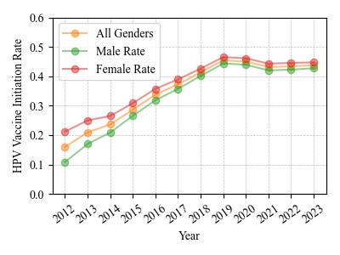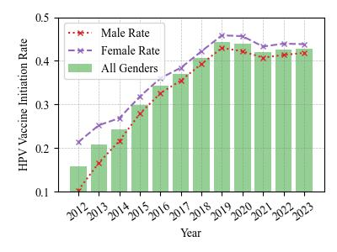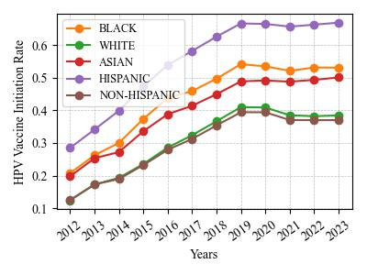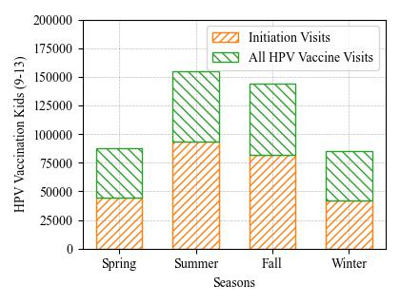

**1.**The percentage on each bar represent the portion of patients who complete the HPV vaccine series towards the patients who initiate the HPV vaccine.

**Figure 3.** The completeness of the HPV vaccinated individuals on the Long Island, New York State, 2012-2023. The figures are generated according to the CDC HPV vaccination guidelines.

1. The Nested Pie Chart shows the HPV Vaccination Patient Doses Schedule and Completeness Proportion.

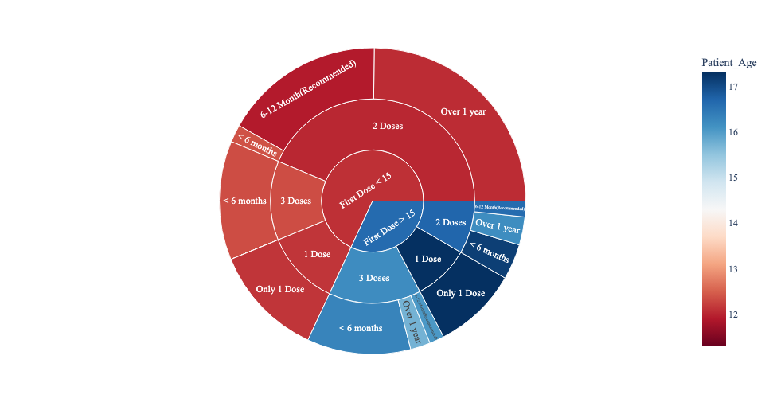

1. HPV Vaccine Series Completion by Gender1
2. HPV Vaccine Series Completion by Race and Ethnicity

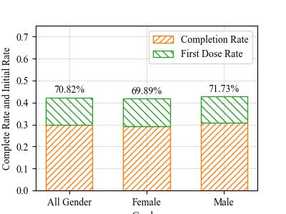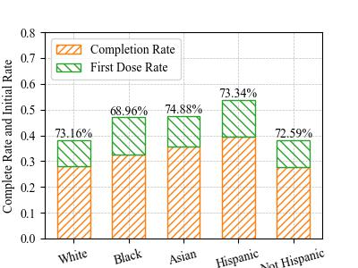

**Figure 4**. Geographical maps of HPV vaccination rates on Long Island, New York (Nassau and Suffolk Counties) among children ages 9-13 by zip code. The rate was calculated by the number of children receiving one or more HPV vaccine dose divided by the number of children who received HPV, Tdap or both vaccines.

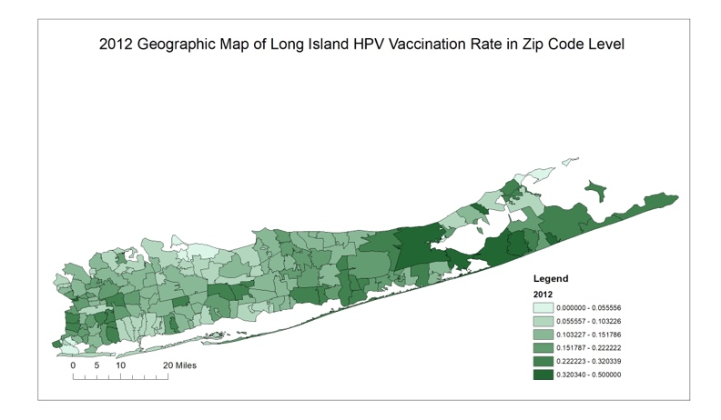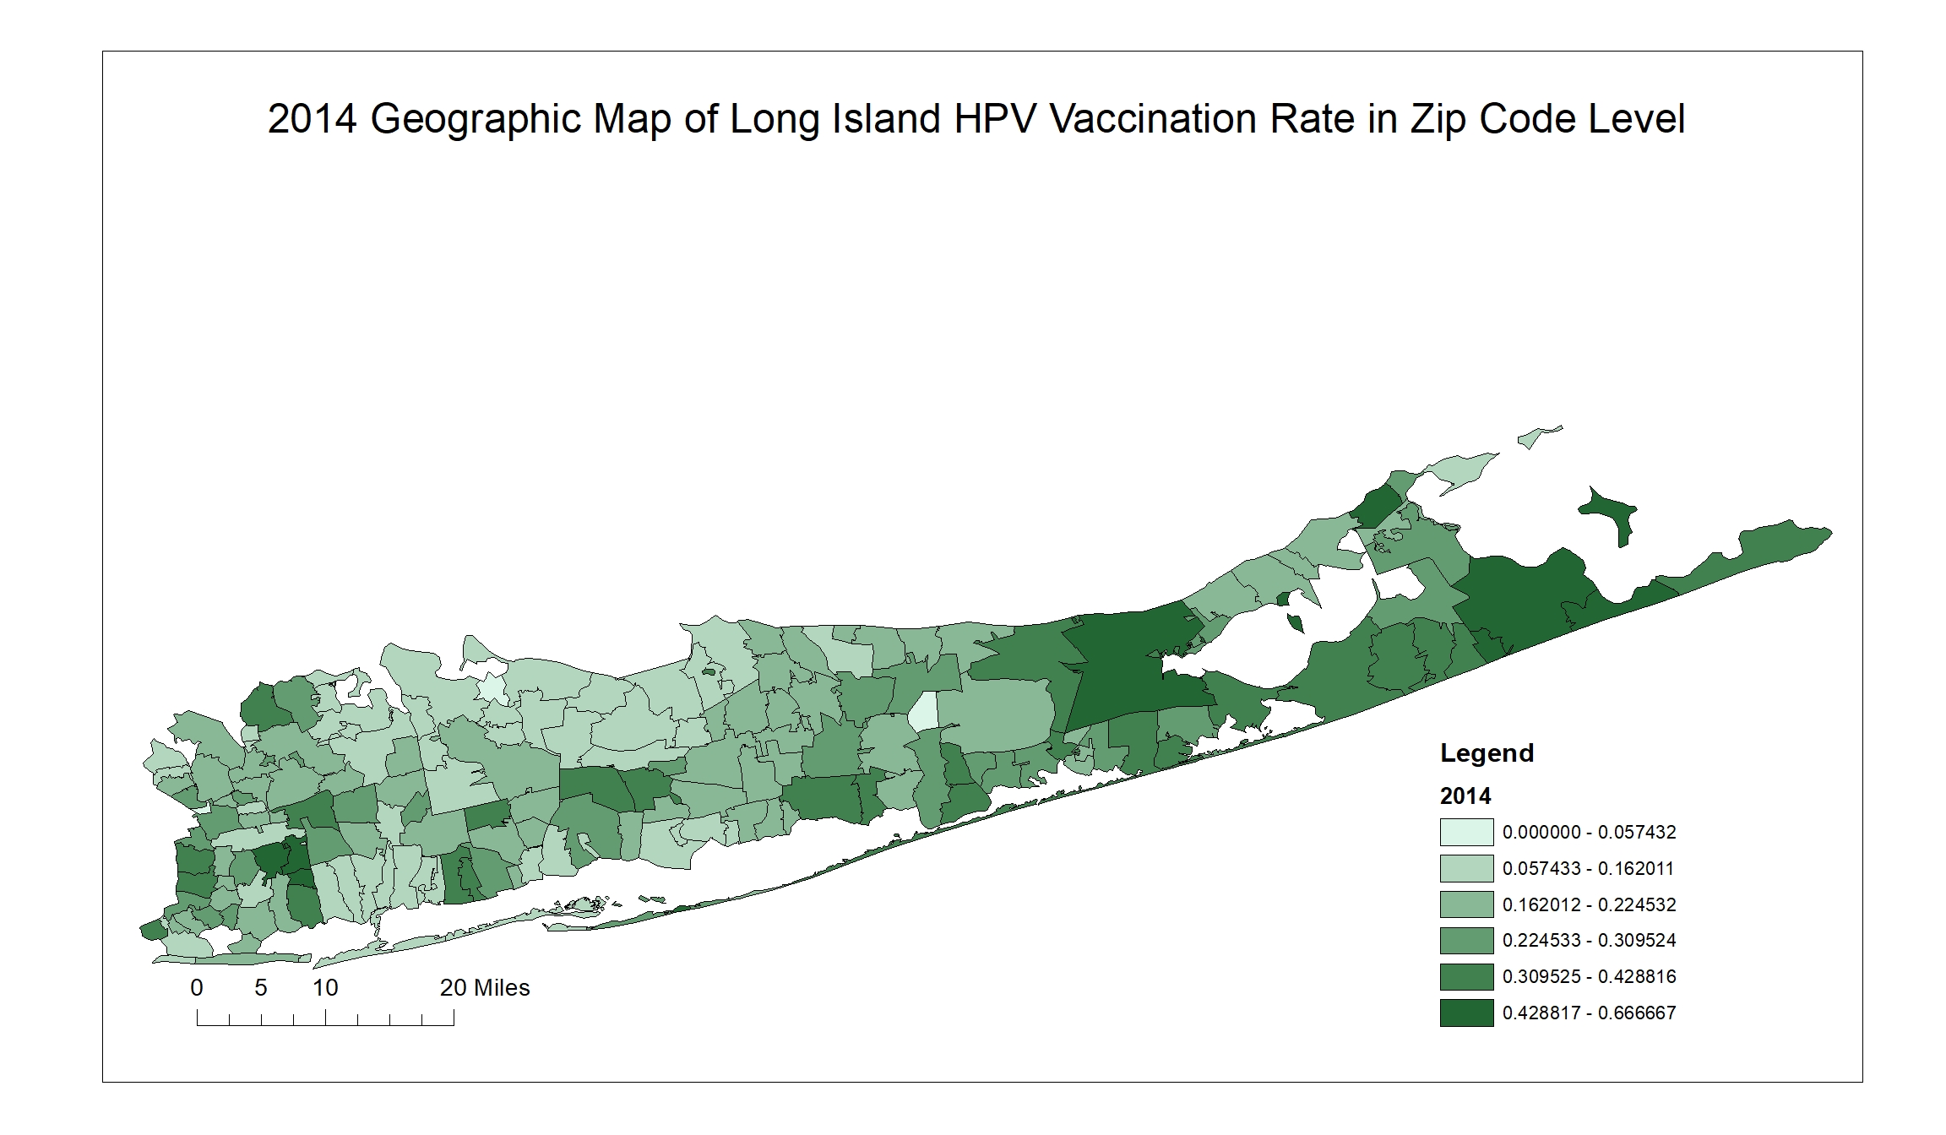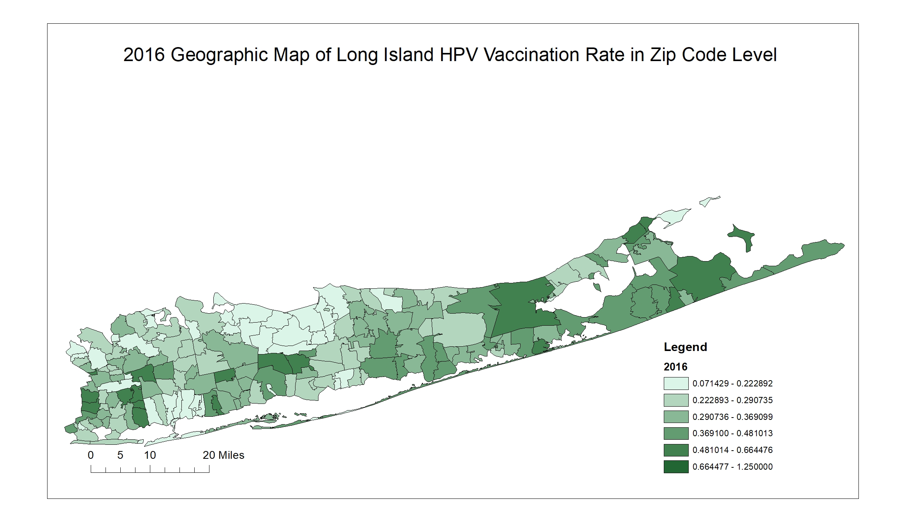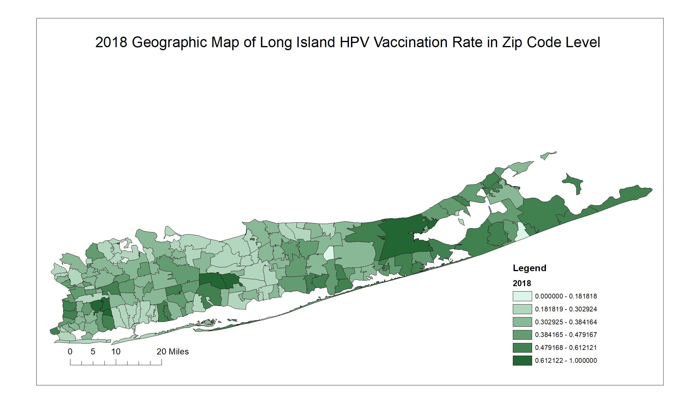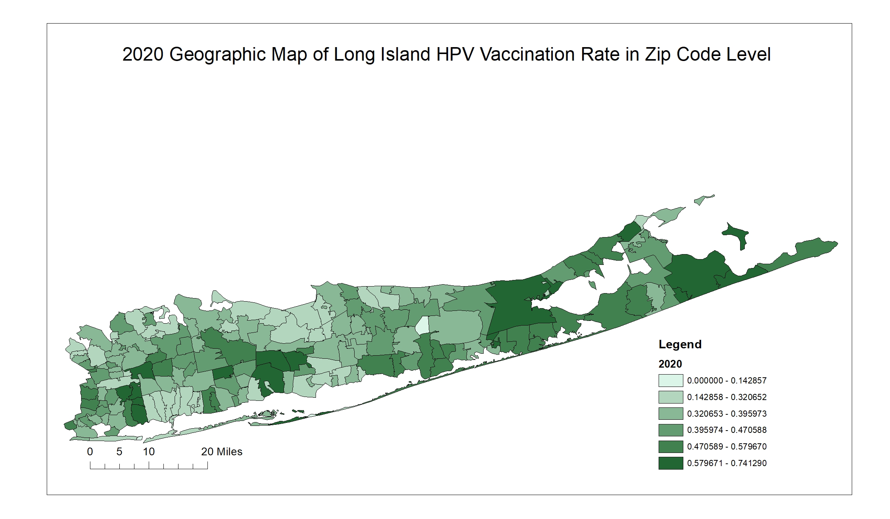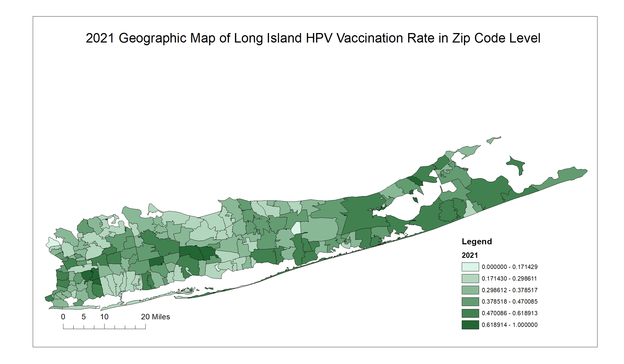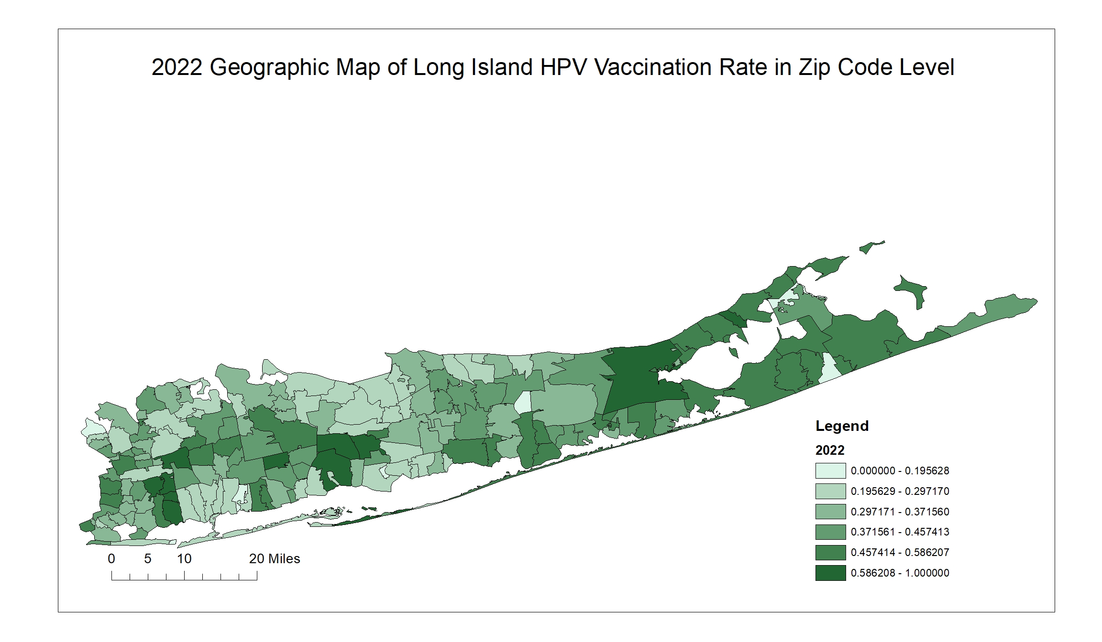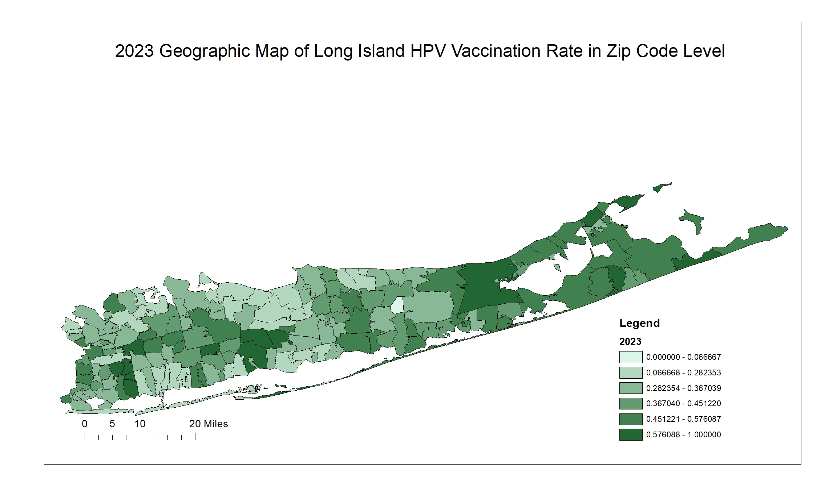

1. (2016) Geographic Map of Long Island HPV Vaccination Rate by Zip Code
2. (2014) Geographic Map of Long Island HPV Vaccination Rate by Zip Code
3. (2018) Geographic Map of Long Island HPV Vaccination Rate by Zip Code
4. (2020) Geographic Map of Long Island HPV Vaccination Rate by Zip Code
5. (2021) Geographic Map of Long Island HPV Vaccination Rate by Zip Code
6. (2022) Geographic Map of Long Island HPV Vaccination Rate by Zip Code
7. (2023) Geographic Map of Long Island HPV Vaccination Rate by Zip Code
8. (2012) Geographic Map of Long Island HPV Vaccination Rate by Zip.